Lab Assignment Ten

Noah Gallego

2024-10-11

# Lab Assignment 10: PCA Analysis on the MTCars Dataset

### Import Libraries

library(dplyr) # For data manipulation

##   
## Attaching package: 'dplyr'

## The following objects are masked from 'package:stats':  
##   
## filter, lag

## The following objects are masked from 'package:base':  
##   
## intersect, setdiff, setequal, union

library(ggplot2) # For plotting  
library(ggrepel) # For Last Plot  
library(factoextra) # For Scree Plot

## Welcome! Want to learn more? See two factoextra-related books at https://goo.gl/ve3WBa

### Exploring the Dataset

data("mtcars")  
df = mtcars  
# Remove Unessecary Columns  
df = df %>% select(c("mpg", "disp", "hp", "drat", "wt", "qsec"))  
  
# Display First Few Columns  
head(df)

## mpg disp hp drat wt qsec  
## Mazda RX4 21.0 160 110 3.90 2.620 16.46  
## Mazda RX4 Wag 21.0 160 110 3.90 2.875 17.02  
## Datsun 710 22.8 108 93 3.85 2.320 18.61  
## Hornet 4 Drive 21.4 258 110 3.08 3.215 19.44  
## Hornet Sportabout 18.7 360 175 3.15 3.440 17.02  
## Valiant 18.1 225 105 2.76 3.460 20.22

# Scale Dataset for PCA  
df_scaled = scale(df)  
apply(df_scaled, 2, sd)

## mpg disp hp drat wt qsec   
## 1 1 1 1 1 1

### Perform PCA

# Perform PCA  
pca = prcomp(df_scaled)  
summary(pca)

## Importance of components:  
## PC1 PC2 PC3 PC4 PC5 PC6  
## Standard deviation 2.0463 1.0715 0.57737 0.39289 0.3533 0.22799  
## Proportion of Variance 0.6979 0.1913 0.05556 0.02573 0.0208 0.00866  
## Cumulative Proportion 0.6979 0.8892 0.94481 0.97054 0.9913 1.00000

# Display Proportion of Variance  
fviz_eig(pca, addlabels = TRUE, ylim = c(0, 100)) # Scree plot showing variance explained by components

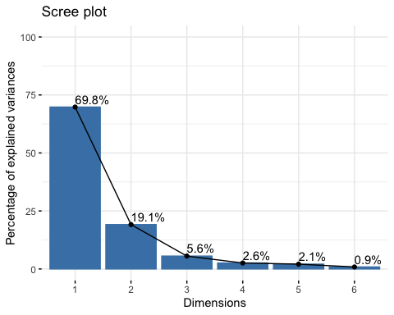

# Examine Loadings  
pca$rotation

## PC1 PC2 PC3 PC4 PC5 PC6  
## mpg -0.4586835 -0.05867609 0.19479235 -0.78205878 0.1111533 -0.35249327  
## disp 0.4660354 0.06065296 -0.09688406 -0.60001871 -0.2946297 0.56825752  
## hp 0.4258534 -0.36147576 -0.14613554 -0.12301873 0.8057408 -0.04771555  
## drat -0.3670963 -0.43652537 -0.80049152 -0.02259258 -0.1437714 0.11277675  
## wt 0.4386179 0.29953457 -0.41776208 -0.10438337 -0.2301541 -0.69246040  
## qsec -0.2528320 0.76284877 -0.34059066 -0.04268124 0.4218755 0.24152663

# Display Biplot  
biplot(pca, scale = 0, cex = c(0.3, 1))

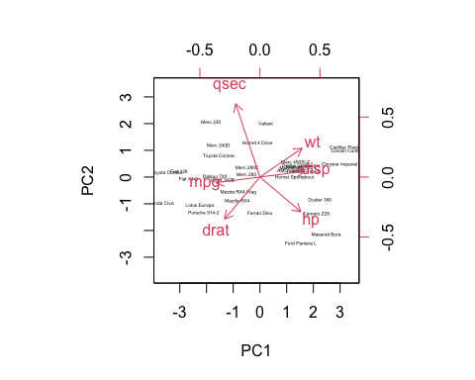

### Diagnostic Plots & Visualizing Principal Components

# Create a data frame with the principal components and model  
pca_df = data.frame(  
 pca$x, model = rownames(df)  
)  
  
variance_explained = pca$sdev^2 / sum(pca$sdev^2)  
# Examine PCA Components on a 2D Plane  
ggplot(pca_df, aes(x = PC1, y = PC2, color = model)) +  
 geom_point(size = 2) +  
 ggtitle("PCA of MTCars Dataset") +  
 xlab(paste0("PC1 (", round(variance_explained[1] * 100, 1), "% Variance)")) +  
 ylab(paste0("PC2 (", round(variance_explained[2] * 100, 1), "% Variance)")) +  
 theme_minimal()

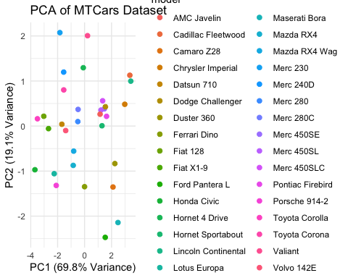

### Outlier Detection

pca_distances = sqrt(rowSums(pca$x[, 1:2]^2))  
outlier_threshold = quantile(pca_distances, 0.95)  
outliers = pca_distances > outlier_threshold  
  
pca_df$outliers = outliers  
  
# Plot the PCA with outliers labeled  
ggplot(pca_df, aes(x = PC1, y = PC2, color = outliers)) +  
 geom_point(size = 2) +  
 geom_text_repel(data = subset(pca_df, outliers), aes(label = model),   
 size = 3, box.padding = 0.5, max.overlaps = Inf) +  
 labs(title = "Outliers Detected Using PCA")

